CURRICULUM VITAE
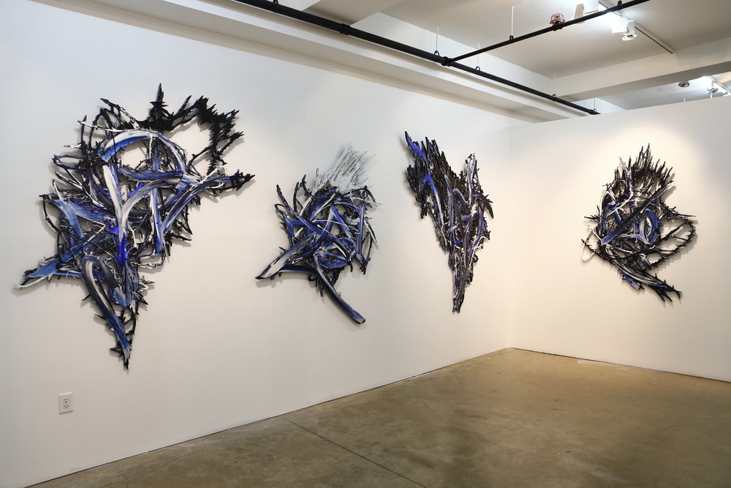
Installation View - GRgallery
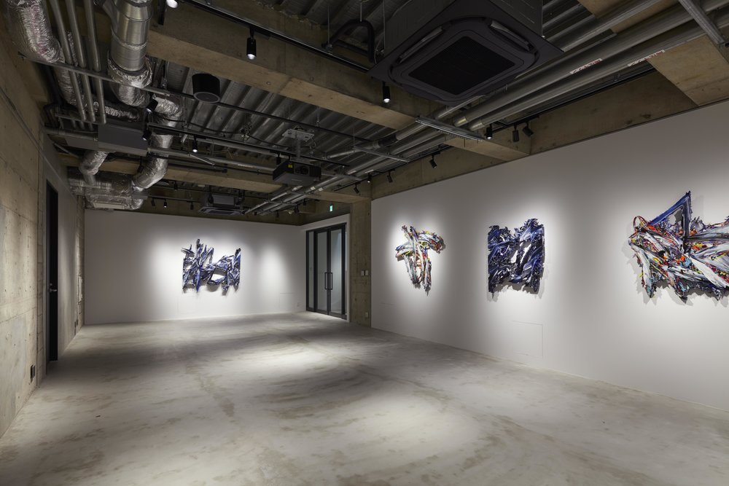
Installation View - Basement GINZA ”SPLITTING HORIZON”
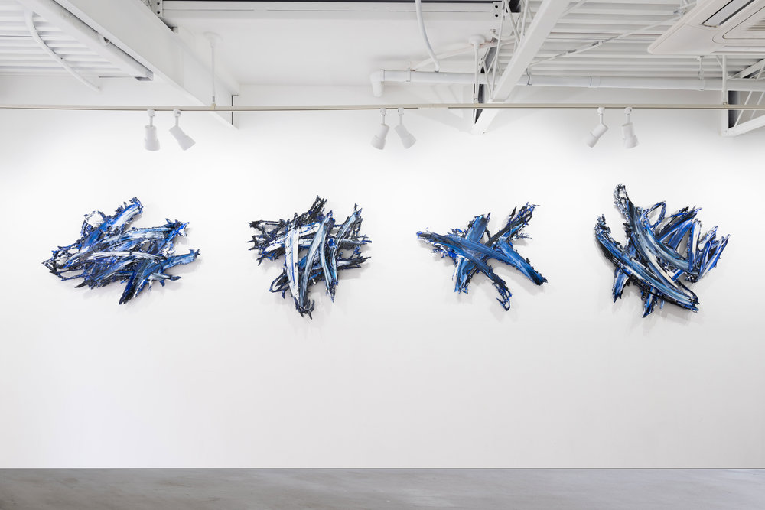
Installation View - MEGURU YAMAGUCHI EXHIBITION「イメージの力」at QUIET NOISE arts & break .2017
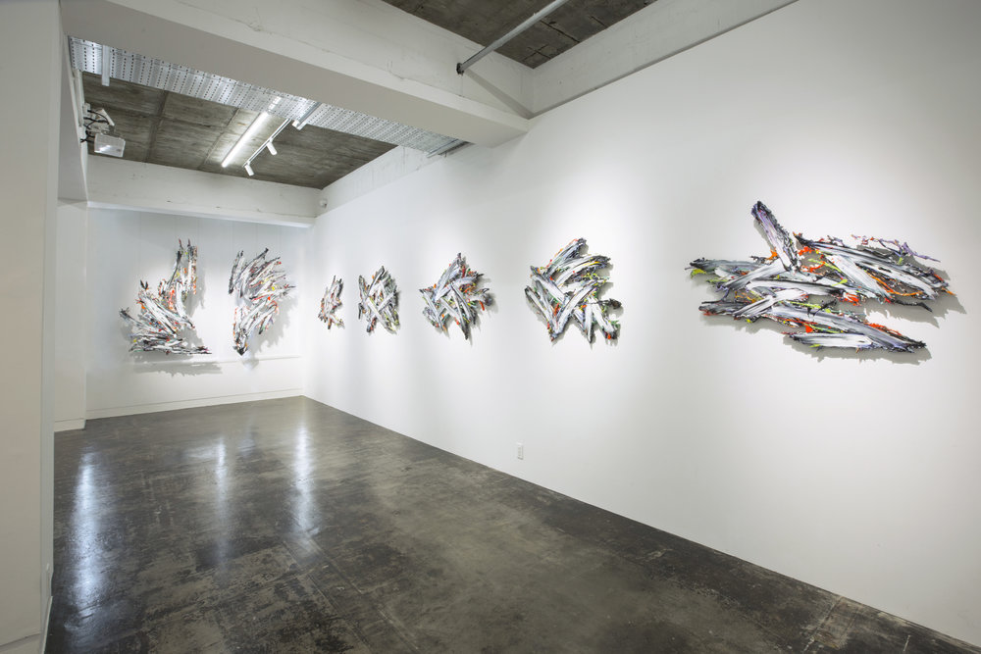
Installation View - MEGURU YAMAGUCHI x KYNE “ STAY GOLD “ at UNION SODA .2017
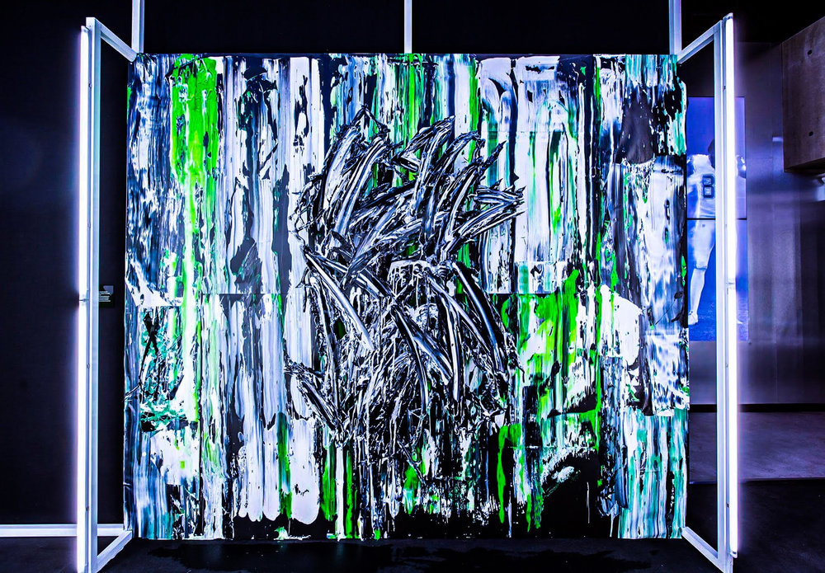
Installation View - NIKE NFL Color Rush 2016
View fullsize
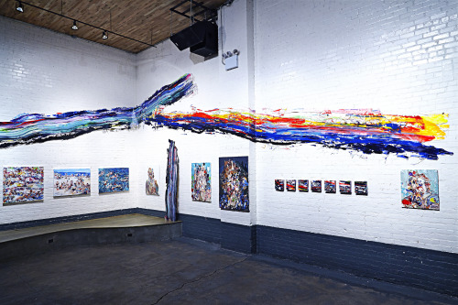
Installation View - Joint Exhibition Chrissy Angliker & Meguru Yamaguchi at 94 KINFOLK, Brooklyn, NY. 2014

SOLO EXHIBITIONS
| 2017 |
SPLITTING HORIZON, Basement GINZA ,Tokyo, Japan
イメージの力 ,QUIET NOISE , Tokyo ,Japan
OUT OF BOUNDS, ELTTOB TEP ISSEY MIYAKE, Tokyo, Japan

| 2016 |
SELL MY SOUL, SAISONART GALLERY, Tokyo, Japan
UNKNOWN SCORCHER, HHH Gallery, Tokyo, Japan

| 2015 |
ALL IS FLUX, NOTHING STAYS STILL, +81 gallery, New York, US

| 2009 |
THE GOLDEN AGE OF REGERMINATION, Mangiami, New York, US

| 2006 |
SHROOM HEADZ EXHIBITION, LEVI’S Arcuate, Tokyo, Japan

GROUP EXHIBITIONS
| 2018 |
Untainted Abstraction , GR gallery , Newyork, NY, US
Kinetic , KINFOLK90 , Newyork NY , US
NIKE ATELIAIR , Tokyo , Japan
| 2017 |
STAY GOLD , UNION SODA ,FUKUOKA, Japan
Nike Color Rush, New York, NY, US

| 2016 |
QUEST, hpgrpgallery, New York, NY US
| 2014 |
NEW PAINTING EXHIBITION - MEGURU YAMAGUCHI & CHRISSY ANGLIKER, KINFOLK 94, Brooklyn, New York, US
BCTION, Tokyo, Japan
HUMAN MACHINERY, +81 gallery, New York, US

| 2013 |
WAH BRIDGE, Bushwick, New York, US.
MONSTER, ANNEX SPACE, New York, US
ART OF JOMON, hpgr GALLERY, New York, US
CITY DRIFT, Bogart Salon, New York, US

| 2012 |
POST DPI, Kaikaikiki Gallery HIDARI ZINGARO, Tokyo, Japan
ART SHOW IN NYU BUSINESS SCHOOL, New York University Stern school of business, New York, US

| 2011 |
NIPPON ZINE, Japan Earthquake Relief Exhibition, The Swatch Group Japan, Nicolas G. Hayek Center, Tokyo, Japan
ART FOR TIBET III GALLERY SHOW AND FUNDRAISER AUCTION, Joshua Liner Gallery, New York, NY, US
GROUPSHOW3, AISHO MIURA ARTS, Tokyo, Japan

| 2010 |
AIR EXHIBITION, SPACE WOMB Gallery, New York, NY, US

| 2008 |
THE ART MARKET PART 2, Destination, New York, NY, US

ART FAIRS
| 2017 |
URBAN ART FAIR NEWYORK 2017, SPRING STUDIOS, New York

| 2016 |
NEW CITY ART FAIR JAPANESE CONTEMPORARY, hpgrp Gallery, New York

| 2013 |
NEW CITY ART FAIR JAPANESE CONTEMPORARY, hpgrp Gallery, New York

| 2012 |
NEW CITY ART FAIR JAPANESE CONTEMPORARY, hpgrp Gallery, New York
| 2011 |
AOSANDO ART FAIR #5, SERGE THORAVAL/H.P.FRANCE, Tokyo, Japan

